Native Dynamic SQL INSERT:

CREATE TABLE EMPLOYEE_NAME (

id NUMBER,

name VARCHAR2(50)

);

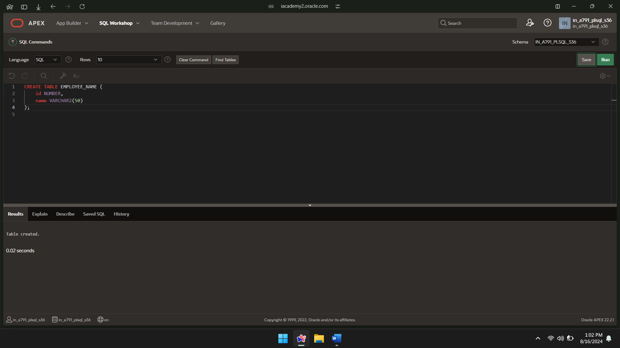

PROCEDURE FOR INSERT:

CREATE OR REPLACE PROCEDURE adding_rows(

p_table_name IN VARCHAR2,

p_id IN NUMBER,

p_name IN VARCHAR2

) IS

BEGIN

EXECUTE IMMEDIATE

'INSERT INTO ' || p_table_name || ' (id, name) VALUES (:1, :2)'

USING p_id, p_name;

END;

/

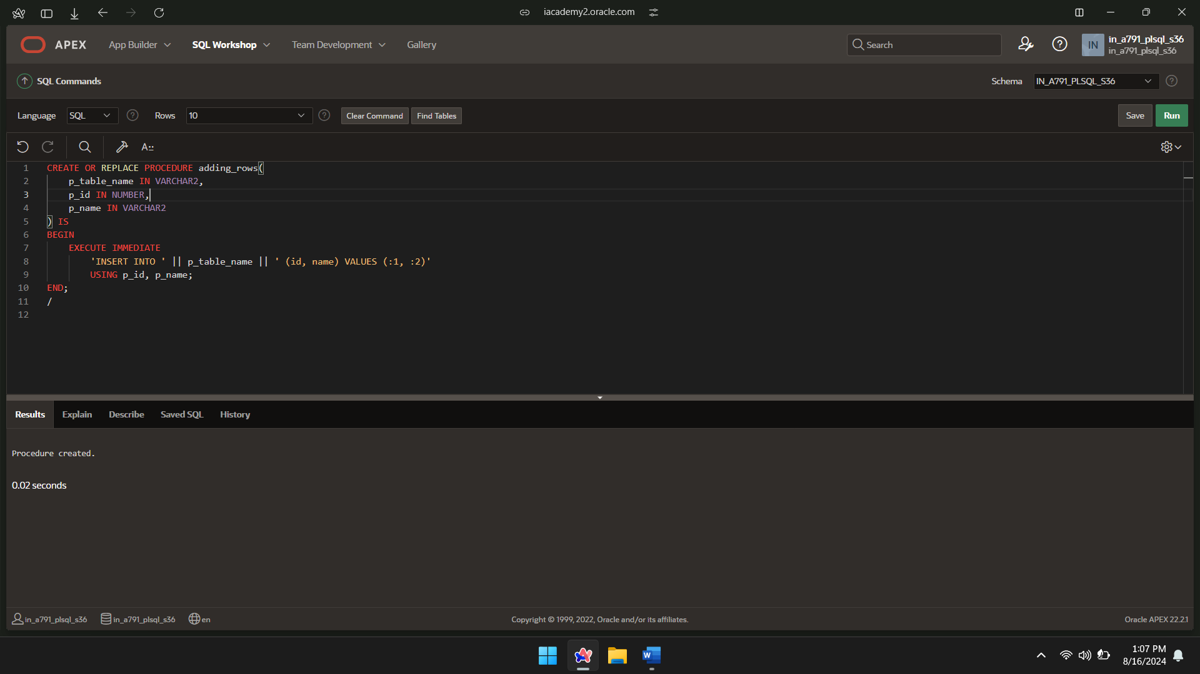

PROCEDURE CALL:

BEGIN

adding_rows('EMPLOYEE_NAME',1,'name1');

END;

/

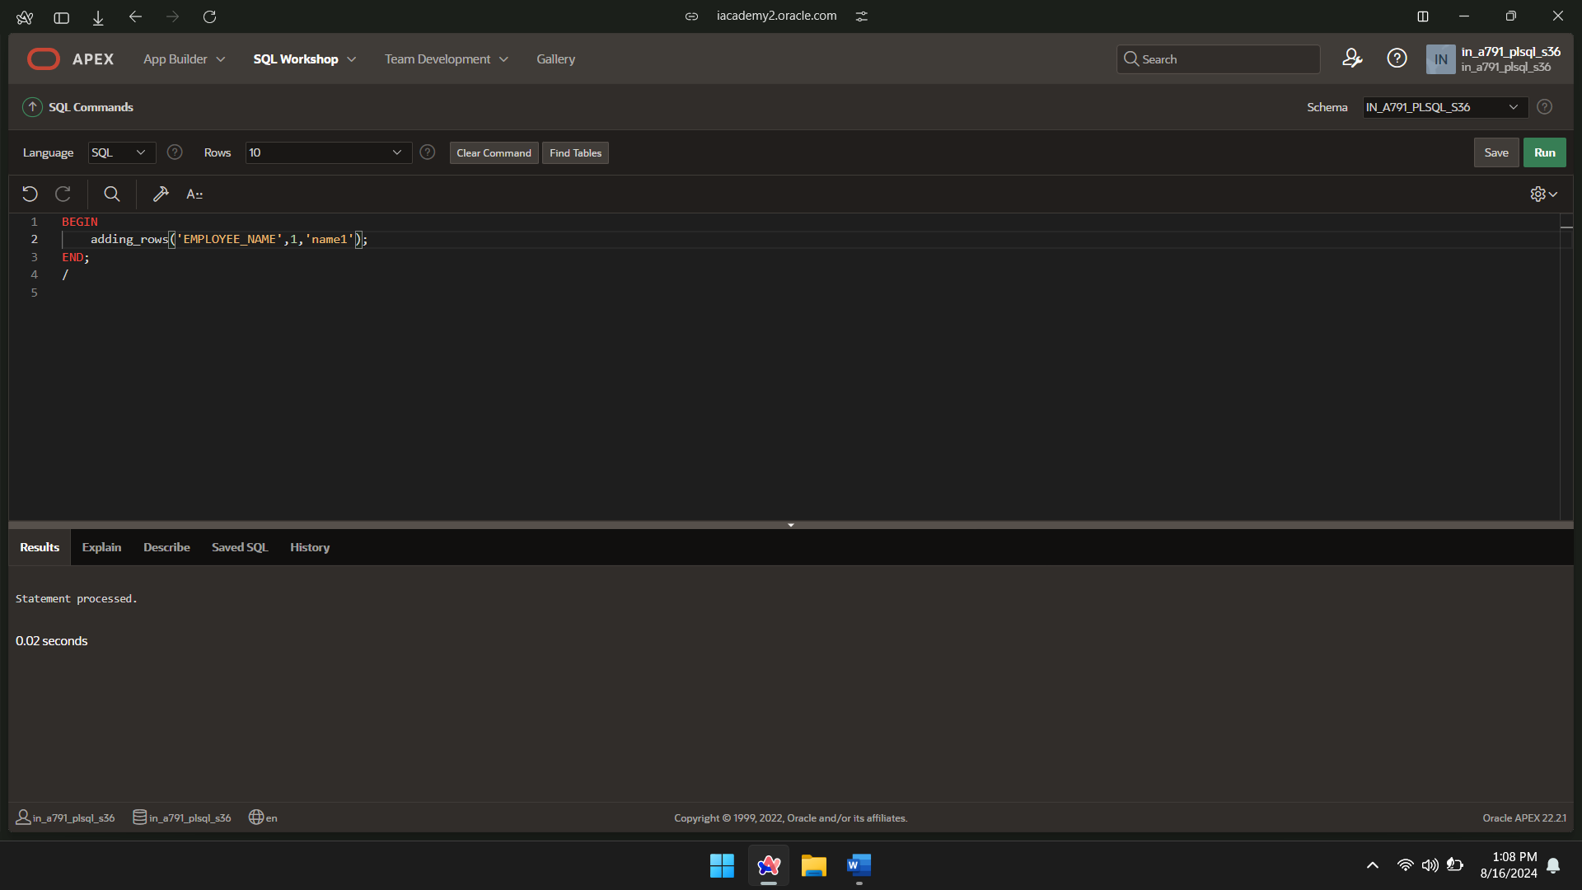

PROCEDURE CALL:

BEGIN

adding_rows('EMPLOYEE_NAME',2,'name2');

END;

/

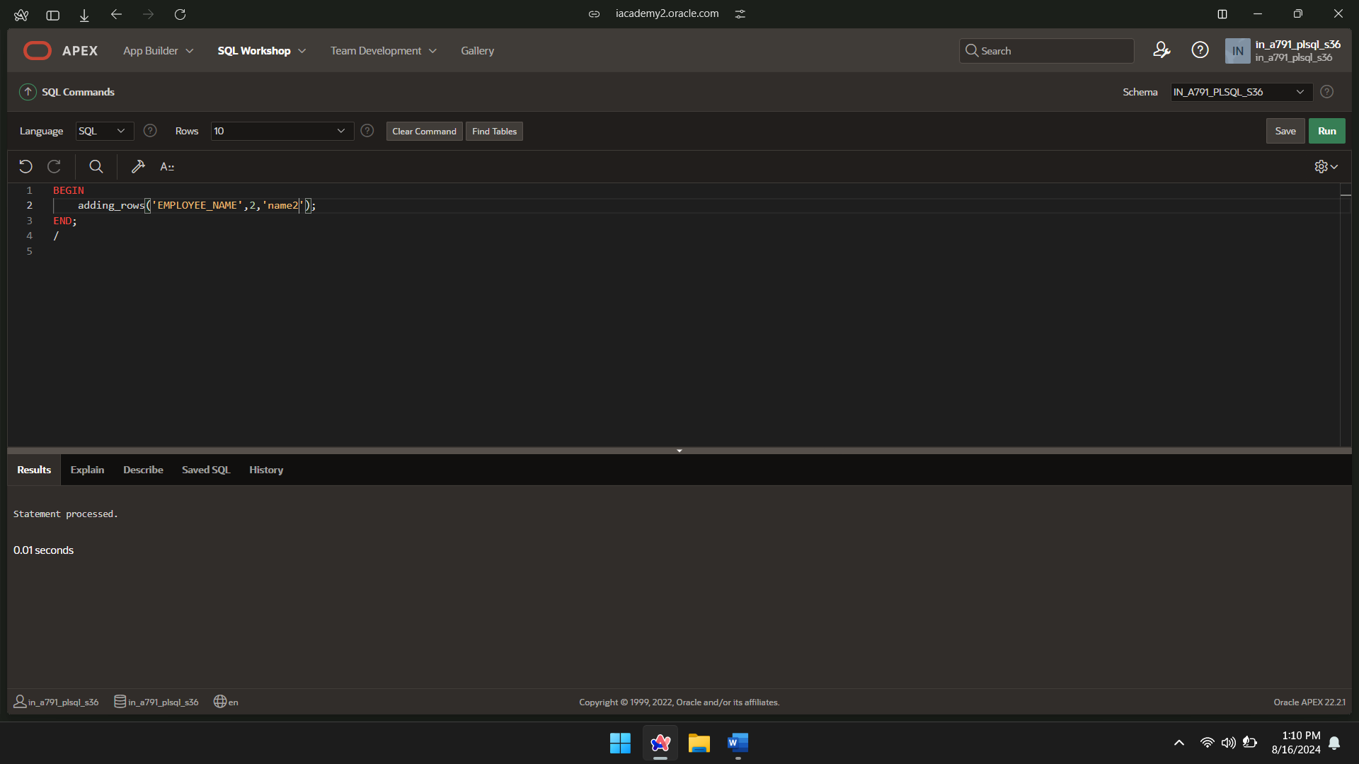

PROCEDURE CALL:

BEGIN

adding_rows('EMPLOYEE_NAME',3,'name3');

END;

/

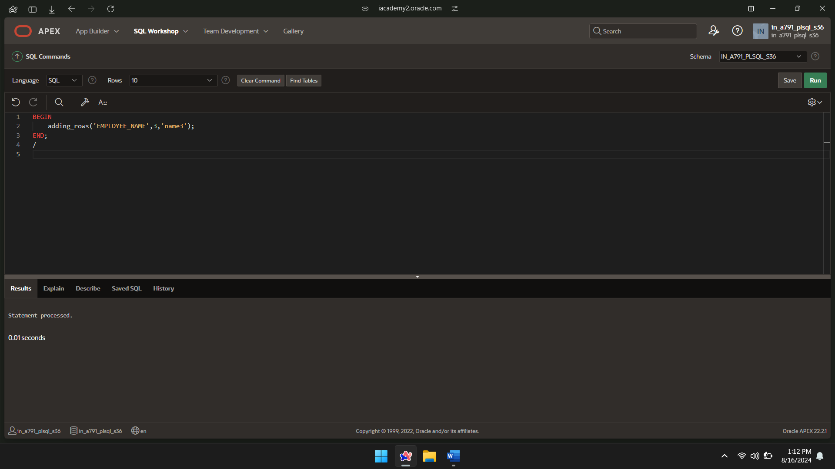

SELECT*FROM EMPLOYEE_NAME;

